Aim: Apply non-linear filters on images and investigate its application in noise-removal.

Theory:-
- Non-linear filters are image processing techniques used for noise removal by considering the
local neighborhood of each pixel. Unlike linear filters, non-linear filters modify pixel values
based on their relationship with neighboring pixels, allowing them to effectively suppress
different types of noise.

Programm:-

import cv2
from google.colab.patches import cv2_imshow

# Read image
img = cv2.imread("/content/smoothening data.png")

# Apply Gaussian Blur filter
filtered_img = cv2.GaussianBlur(img, (7, 7), 0)

# Show image inline in Colab
cv2_imshow(filtered_img)

# Save filtered image
cv2.imwrite("filtered_image.jpg", filtered_img)
print("Filtered image saved as 'filtered_image.jpg'")

Filtered image saved as 'filtered_image.jpg

Output:-

Original Image | Non Linear Image
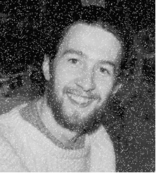 | 

Observation:
The original image contained some noise or irregularities that affected its visual quality.
- After applying the Gaussian Blur (a non-linear filter), the filtered image appears smoother, with noise significantly reduced.
- Fine details and sharp edges are slightly softened due to the averaging effect of the filter.
- The filter effectively reduces high-frequency variations (noise) while preserving general shapes and structures in the image.

Conclusion:In this experiment, we learned that non-linear filters, like Gaussian Blur, effectively remove noise from images by smoothing pixel values based on their neighbors. This improves image quality while preserving overall structure, making it useful for image processing and analysis.

